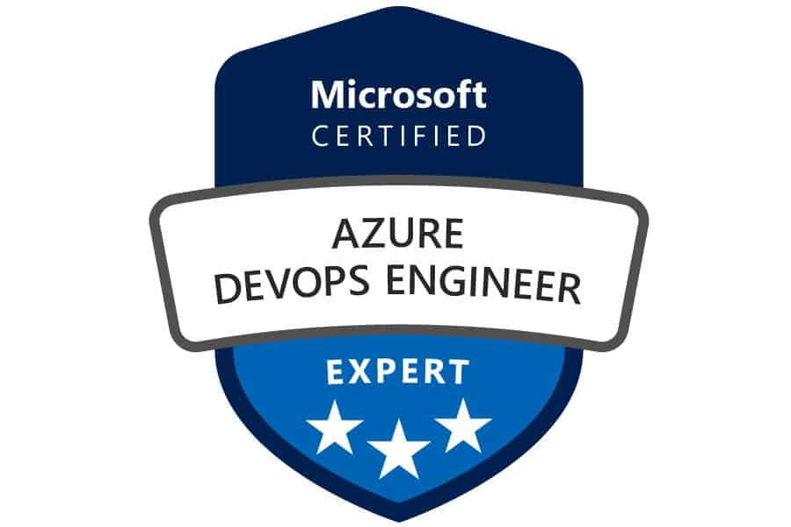

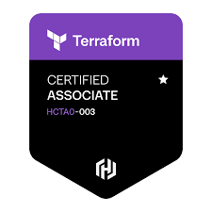
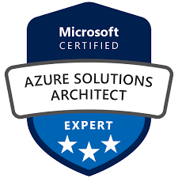
ESWARA RAO SEERA
Email: emaniv@i-giants.com
Mob: +1 913-357-8881
LinkedIn: ESWARA RAO SEERA

PROFESSIONAL SUMMARY
- Total 15+ years of experience in Cloud Architecture, DevOps, Platform Engineering, and Infrastructure Management supporting large-scale enterprise and banking environments.
- Seasoned Principal Cloud Architect with strong hands-on expertise in designing, building, and operating secure, scalable, and highly available Microsoft Azure platforms.
- Extensive experience leading enterprise cloud transformation initiatives, including legacy modernization, cloud migration, and platform standardization.
- Deep working knowledge of Microsoft Cloud Adoption Framework (CAF) and Azure Well-Architected Framework, applying best practices across governance, security, reliability, and cost optimization.
- Proven expertise in architecting Azure Landing Zones, management group hierarchies, subscription strategies, and enterprise governance models.
- Strong background in designing hybrid and multi-cloud solutions integrating on-premises infrastructure with Azure-native services.
- Demonstrated leadership in DevOps and CI/CD automation using Azure DevOps, GitHub Actions, and Jenkins to enable faster, reliable, and secure software delivery.
- Extensive hands-on experience implementing Infrastructure as Code using Terraform, ARM templates, and Bicep for standardized, repeatable deployments.
- Strong expertise in Azure networking and security architectures including hub-and-spoke models, Azure Firewall, Private Endpoints, NSGs, VPN Gateway, and ExpressRoute.
- Proven experience designing and operating container platforms using Azure Kubernetes Service (AKS), Helm-based deployments, and advanced rollout strategies.
- Strong focus on cloud security, compliance, and identity management using Azure AD (Entra ID), RBAC, Azure Policy, Key Vault, and Zero Trust principles.
- Demonstrated success driving FinOps initiatives and cloud cost optimization through rightsizing, governance, and consumption monitoring.
- Trusted advisor to senior stakeholders, translating business requirements into practical, scalable, and secure cloud solutions.
- Experienced mentor and technical leader guiding cloud, DevOps, and platform engineering teams across enterprise programs.

KEY ACHIEVEMENTS
- Played a key role in large-scale cloud transformation programs for global banking clients, helping move legacy platforms to secure, scalable Azure-native and hybrid cloud environments.
- Simplified and accelerated infrastructure delivery by standardizing Azure Landing Zones, Terraform modules, and CI/CD pipelines, significantly reducing provisioning and deployment timelines.
- Improved overall cloud security and audit readiness by implementing practical Zero Trust controls, Azure Policy, RBAC, and centralized secrets management using Key Vault.
- Increased platform stability and resilience by designing reliable backup, disaster recovery, monitoring, and SIEM solutions aligned with business RTO and RPO expectations.
- Enabled development teams to release applications faster and with more confidence by introducing container platforms, AKS-based deployments, and safer rollout strategies such as blue-green and canary releases.
- Helped organizations gain better control over cloud costs by applying FinOps practices, resource rightsizing, and governance controls, resulting in sustained and measurable cost savings.
CERTIFICATIONS
- HashiCorp Certified: Terraform Associate (003)
- Microsoft Azure Administrator Associate (AZ-104)
- Microsoft Azure DevOps Engineer Expert (AZ-400)
- Microsoft Azure Solutions Architect Expert (AZ-305)

TECHNICAL SKILLS
Cloud Platforms – Azure | AKS, Virtual Machines, VM Scale Sets, App Service, Azure Functions, API Management, Logic Apps, Service Bus, Event Hub, Key Vault, DNS, ExpressRoute, Load Balancer, Application Gateway (WAF), VPN Gateway, Azure Front Door, Traffic Manager, Private Endpoints, Azure Monitor, Application Insights, Log Analytics, Recovery Services Vault, Azure Backup, Azure Site Recovery, Microsoft Sentinel, Azure Data Lake, Azure Databricks, Azure Purview
Cloud Platforms – AWS | EC2, RDS, S3, Lambda, VPC, IAM, Auto Scaling, CloudFormation, Elastic Load Balancing, Route 53, Elastic Beanstalk, ElastiCache, SNS, SQS, MQ, ECS, EKS, Fargate, CloudWatch, Grafana
Programming & Scripting | Python, PowerShell, Bash / Shell Scripting, SQL, PL/SQL, Java (working knowledge)
Frameworks & Patterns | Microservices Architecture, RESTful Web Services, Event-Driven Architecture, Client-Server, MVC
DevOps & CI/CD | Azure DevOps, GitHub Actions, Jenkins (Groovy Pipelines), CI/CD Security, Release & Approval Workflows
Infrastructure as Code | Terraform (custom modules, remote state, workspaces), ARM Templates, Bicep, Ansible
Version Control | Git, GitHub, Bitbucket, SVN
Containerization | Docker, Kubernetes, Azure Kubernetes Service (AKS), Helm (Helm 3)
Code Quality & Security | SonarQube, Static Code Analysis, Security Scanning
Databases | Azure SQL, Cosmos DB, MS SQL Server, Oracle (basic exposure)
Monitoring & Observability | Azure Monitor, Application Insights, Log Analytics, Prometheus, Grafana, ELK Stack, Datadog, Splunk
Identity & Security | Azure AD (Entra ID), IAM, RBAC, MFA, Key Vault, Zero Trust Architecture
ITSM & Tools | Jira, ServiceNow, Remedy

PROFESSIONAL EXPERIENCE

Client: Citi Bank – Seffner, FL Apr 2025 – Present
Role: Principal Cloud & DevOps Architect
Project Summary:
Leading enterprise Azure cloud architecture and DevOps initiatives supporting mission-critical banking platforms with a strong focus on governance, security, CI/CD automation, and scalability.
Responsibilities:
- Designed and implemented enterprise Azure architectures across IaaS, PaaS, and AKS workloads.
- Assessed existing Azure environments and remediated security, reliability, and cost inefficiencies using Azure Well-Architected Framework.
- Architected Azure Landing Zones with standardized identity, networking, and governance models.
- Designed hub-and-spoke networking using Azure Firewall, Private Endpoints, NSGs, VPN Gateway, and ExpressRoute.
- Built standardized CI/CD pipelines using Azure DevOps and GitHub Actions with approval gates and rollback strategies.
- Developed reusable Terraform modules and ARM templates for auditable infrastructure provisioning.
- Implemented enterprise backup and disaster recovery using Azure Backup and Azure Site Recovery meeting strict RTO/RPO requirements.
- Integrated centralized monitoring, logging, and SIEM using Azure Monitor and Microsoft Sentinel.
- Provided architecture reviews, best practices, and guidance to senior stakeholders and delivery teams.
Environment: Azure (IaaS, PaaS, AKS), Azure DevOps, GitHub Actions, Terraform, ARM Templates, Azure Firewall, Azure Monitor, Log Analytics, Microsoft Sentinel, PowerShell, Git, Jira

Client: UOB Bank – Singapore Nov 2021 – Apr 2025
Role: Senior Cloud Architect / DevOps Lead
Project Summary:
Modernized enterprise Azure platforms to enable secure cloud adoption, DevOps automation, and governance at scale.
Responsibilities:
- Led Azure platform modernization aligned with CAF and Azure Well-Architected Framework.
- Designed Azure Landing Zones with hub-and-spoke networking and shared services.
- Built CI/CD pipelines using Azure DevOps and GitHub Actions integrating security and approvals.
- Authored Terraform modules for networking, compute, storage, and identity.
- Enforced governance using Azure Policy, RBAC, and management groups.
- Designed and tested backup and disaster recovery strategies.
- Established centralized monitoring and SIEM solutions.
- Mentored cloud and DevOps engineering teams.
Environment: Azure, AKS, Azure DevOps, GitHub Actions, Terraform, Azure Policy, RBAC, Azure Monitor, Microsoft Sentinel, PowerShell, Git, Jira

Client: BNP Paribas – Singapore Jul 2018 – Nov 2021
Role: Azure & DevOps Architect
Project Summary:
Delivered CI/CD automation and container modernization initiatives enabling cloud-native deployments.
Responsibilities:
- Built CI/CD pipelines in Azure DevOps integrating SonarQube and artifact repositories.
- Containerized legacy applications and deployed to AKS using Docker and Helm.
- Implemented blue-green and canary deployments using Azure Front Door and Traffic Manager.
- Provisioned infrastructure using Terraform and ARM templates.
- Designed observability using Azure Monitor, Prometheus, and Grafana.
Environment: Azure, AKS, Azure DevOps, Terraform, ARM Templates, Docker, Kubernetes, Helm, Prometheus, Grafana, SonarQube

Client: Citi Bank – Singapore Feb 2017 – Jul 2018
Role: Cloud & DevOps Engineer
Project Summary:
Built and supported enterprise CI/CD platforms and Kubernetes-based deployments.
Responsibilities:
- Designed Jenkins-based CI/CD pipelines using Groovy.
- Integrated Jira, Bitbucket, SonarQube, and JFrog Artifactory.
- Built OpenShift-native Jenkins pipelines.
- Managed Helm-based Kubernetes deployments.
Environment: Jenkins, Groovy, OpenShift, Docker, Kubernetes, Helm, Jira, Bitbucket, SonarQube, JFrog Artifactory

Client: JPMorgan Chase – India Jan 2015 – Jan 2017
Role: Cloud & DevOps Engineer
Project Summary:
Supported AWS-based cloud infrastructure and DevOps automation.
Responsibilities:
- Provisioned AWS infrastructure using EC2, S3, RDS, ELB, Auto Scaling, and Route 53.
- Automated provisioning using CloudFormation and Ansible.
- Implemented monitoring using CloudWatch and Datadog.
- Designed high-availability and disaster recovery architectures.
Environment: AWS, CloudFormation, Ansible, CloudWatch, Datadog, Linux

Client: Syntel Ltd – India Sep 2011 – Jan 2015
Role: Production Support Engineer
Project Summary:
Provided 24×7 production support and automation for enterprise batch processing systems.
Responsibilities:
- Monitored production systems to meet SLA requirements.
- Automated monitoring and self-healing scripts using Shell scripting.
- Built dashboards and alerts using Geneos ITRS.
Environment: Linux, Shell Scripting, Geneos ITRS, Batch Monitoring

EDUCATION Bachelor of Engineering (B.E.) – 2011
Jawaharlal Nehru Technological University, Kakinada (JNTUK)

